

**INSTALLATION MANUAL**

### Table of Contents

### Applicable Version………………..….……………………………….……………………….………1

### Installation....………………………….……….………………………………………………………….1

### Configuring Ingenico……………………………………………………………………………………3

### Applicable versions

|  |  |
| --- | --- |
| **Applications** | **Versions** |
| PHP | 7.x to 7.4.x |
| Magento | 2.0.x to 2.4.x |

**Installation & Upgrade**

Please follow the given steps to install and run the Ingenico Payment Gateway module

1. Unzip extension package and upload them into Magento root directory.

You will get the “Ingenico” folder under the app/code folder. In case, of upgrade replace the folder

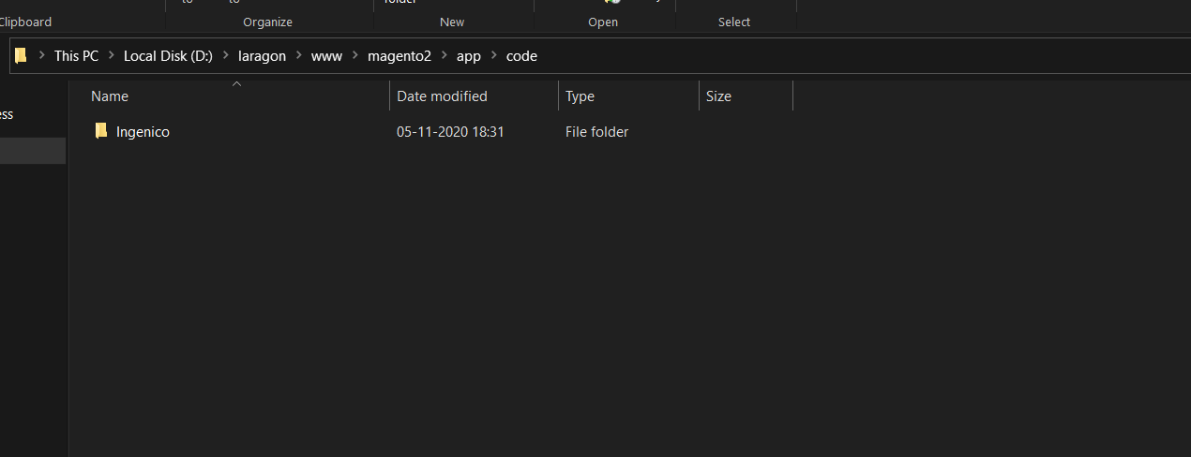

2.Enable the module with the following commands

*php bin/magento module:enable Ingenico_Ingenico*

3. Enter the following at the command line to enable the module.

*php bin/magento setup:upgrade*

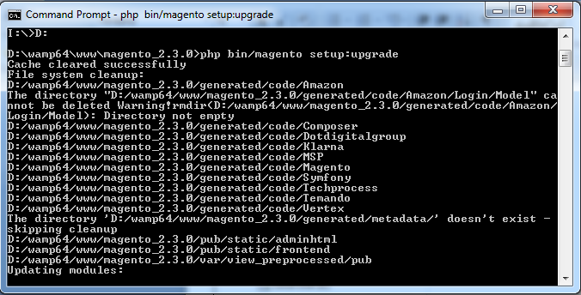

4. Enter below to generate the classes required for the extension to work  
 *php bin/magento setup:di:compile*

5. Enter below command for static-content deploy to reflect changes on site.

*php bin/magento setup:static-content:deploy*

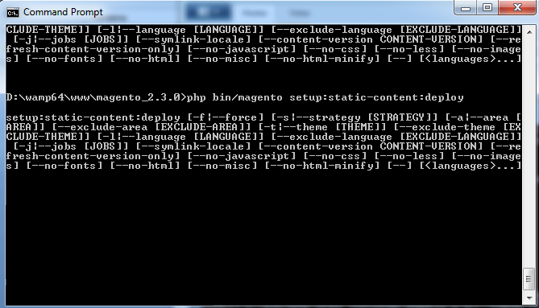

**Configuring Ingenico**

1. Go-to admin panel.
2. Go-to menu Stores -> Configuration.
3. Select “Payment methods” under the “Sales” tab on the left panel.
4. Click on Ingenico Payment Gateway.
5. Configure it as below:

|  |  |
| --- | --- |
| **Column Name** | **Description** |
| Enabled | “Yes” to enable and use, else “No” to disable ingenico |
| Title | Title Text to display during checkout process |
| Salt | Enter Salt. |
| Merchant Code | Enter merchant code. |

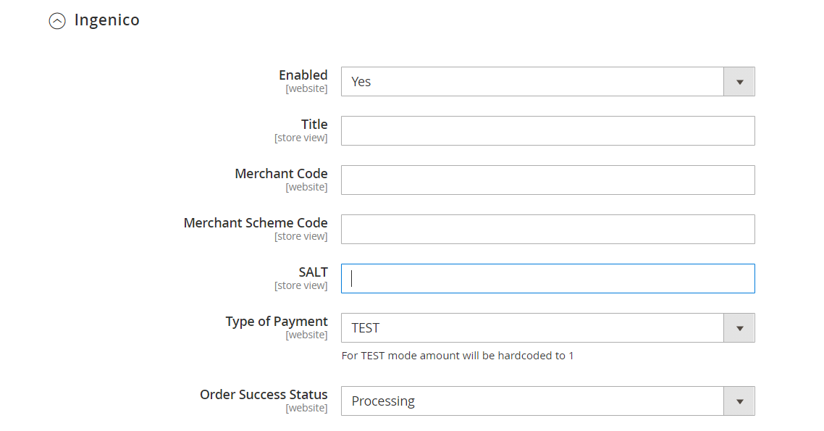

1. Now click on “Save Config” on top- right corner.
2. Ingenico Payment Gateway is now configured & ready to use.

**Advanced Configuration**

There are also some advanced configuration options you may consider as shown below:

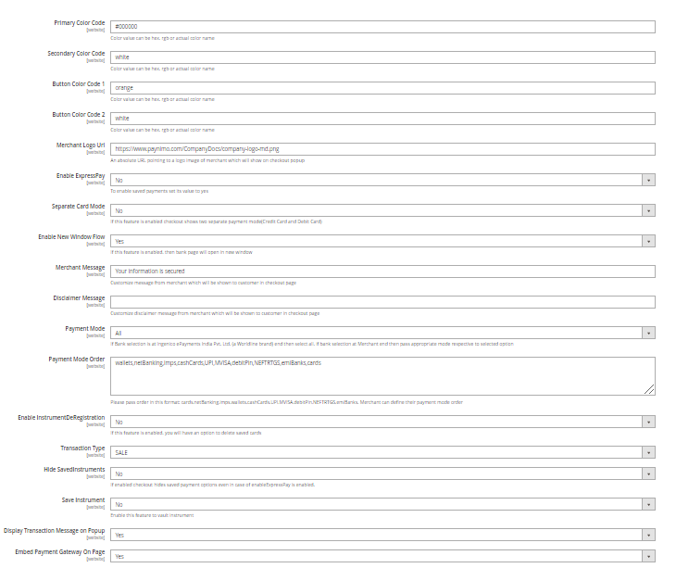

## **Features List**

### Dual verification of response:

We are validating responses with a hash value and call again Payment Gateway for dual verification from the payment gateway before updating to the order status.

### Reconciliation

Merchants can update the pending status of the order automatically if the payments are successful. This page can be found under Sales > Ingenico > Reconciliation

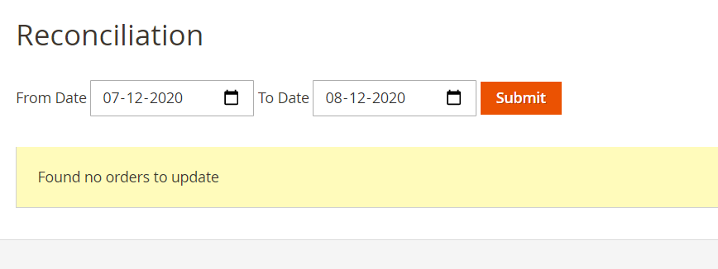

### Logs request and response

Daily new file creates for the logs request and response from the server for future reference.

### S2S Verification

If we do not receive any response from the payment gateway then after 30 mins, we will get a response from the server and based on the response it will update order status.

To configure S2S URL, contact prod team.

S2S url format : [http://DOMAIN_NAME/index.php/ingenico/payment/s2sverification](http://domain_name/index.php/ingenico/payment/s2sverification) or [https://DOMAIN_NAME/index.php/ingenico/payment/s2sverification](http://domain_name/index.php/ingenico/payment/s2sverification)

S2S url example : [http://example.com/index.php/ingenico/payment/s2sverification](http://localhost/magento_mirror/index.php/ingenico/payment/s2sverification)

### MCG

It supports the multi currency like USD, GBP, SGD and a lot more.

### Payment Verification

Merchants can verify the status of their payment by using the Payment Verification page. The payment verification page can be found under sales > Ingenico > Payment Verification

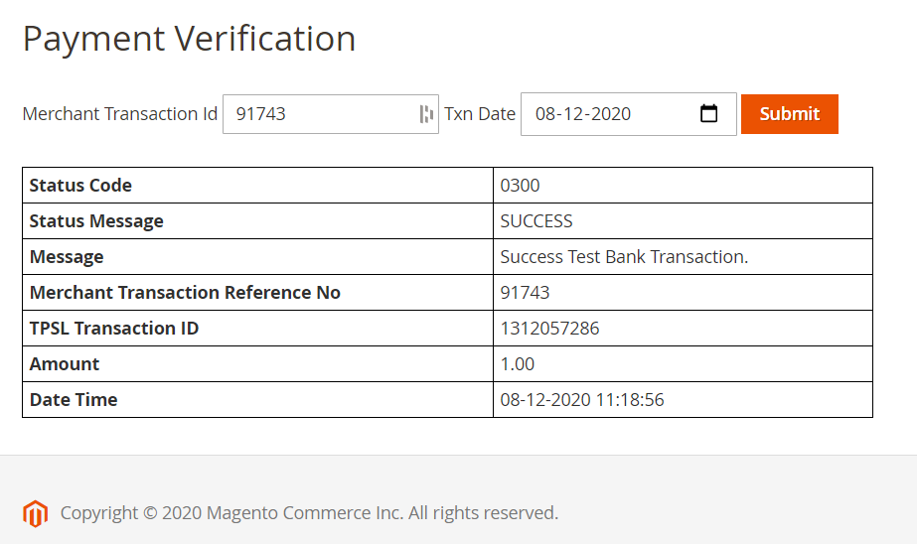

### Refund

Merchants should be able to process the refund online for the order whose payment has been done via Ingenico.

To refund a order, create a new Credit Memo and click on the Refund button as shown below

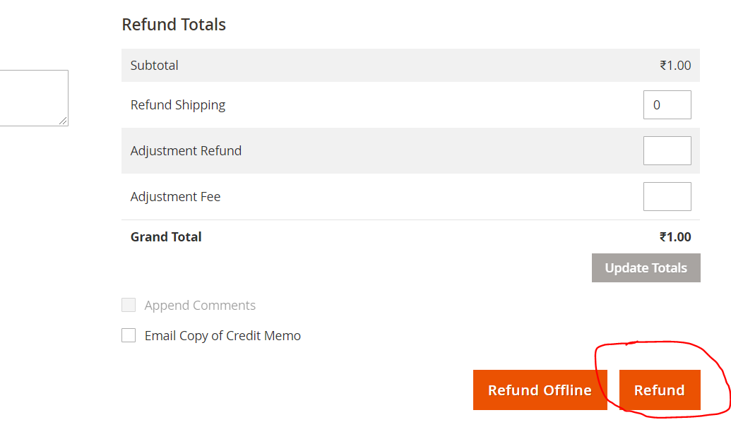

### Embed Payment Gateway

After enabling this setting, payment gateway displays like embedded on the page instead of pop-up so user experience would be good.

## Documentation link

[**https://www.tecprocesssolution.com/proto/p2m/client/salt-based-documentation.htm#online**](https://www.tecprocesssolution.com/proto/p2m/client/salt-based-documentation.htm#online)